# Exercises: How to trade on Bittrex

This document describes the **exercise assignments** for the ["Blockchain Academy" course @ Software University](https://softuni.bg/courses/programming-fundamentals). . In this lesson we learned about Cryptocurrency buying platforms and exchanges. In this exercise we shall register in Bittrex, make trades and send transactions in order to get familiar with the way exchanges work.

## Register in Bittrex

1. First, we shall register in **Bittrex**.
2. Click this link to visit the **"Sign Up"** page: <https://www.bittrex.com/Account/Register/>
3. Enter your email address into the **"E-mail address"** field
4. Enter a password in the **"Password"** field.  Passwords must be at least 8 characters long and it is preferred that you use 12 or more characters to enhance your passwords security.
5. Re-enter the same password in the **"Confirm password"** field.
6. Check the box next to **"I'm not a robot"** to prove you are human.
7. Your screen should look similar to this:

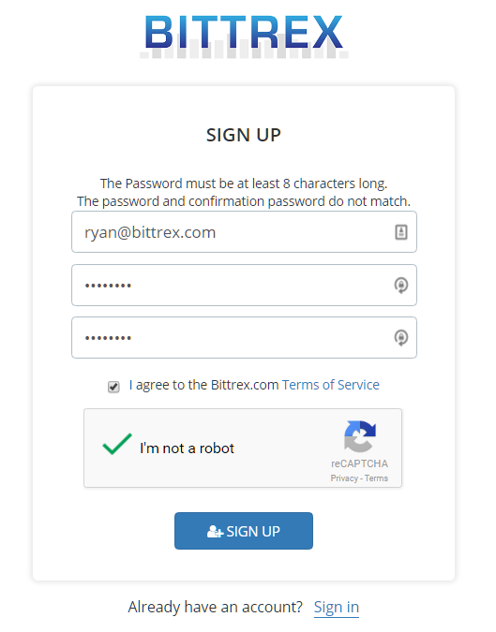

1. In order to complete the registration process you will need to open your email and look for an email from **"Bittrex Mailer"** with the subject **"Bittrex Account Verification"**
2. Open the email and click the **Verify Registration link**.
3. Once you have completed this process, you have **successfully registered your account at Bittrex**.

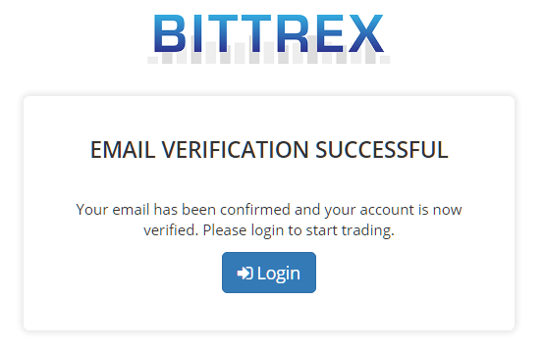

## Deposit Your Cryptocurrency

1. Now you have a registration. Let’s log in and explore the interface of **Bittrex**. Open <https://bittrex.com> and click **LOGIN**.

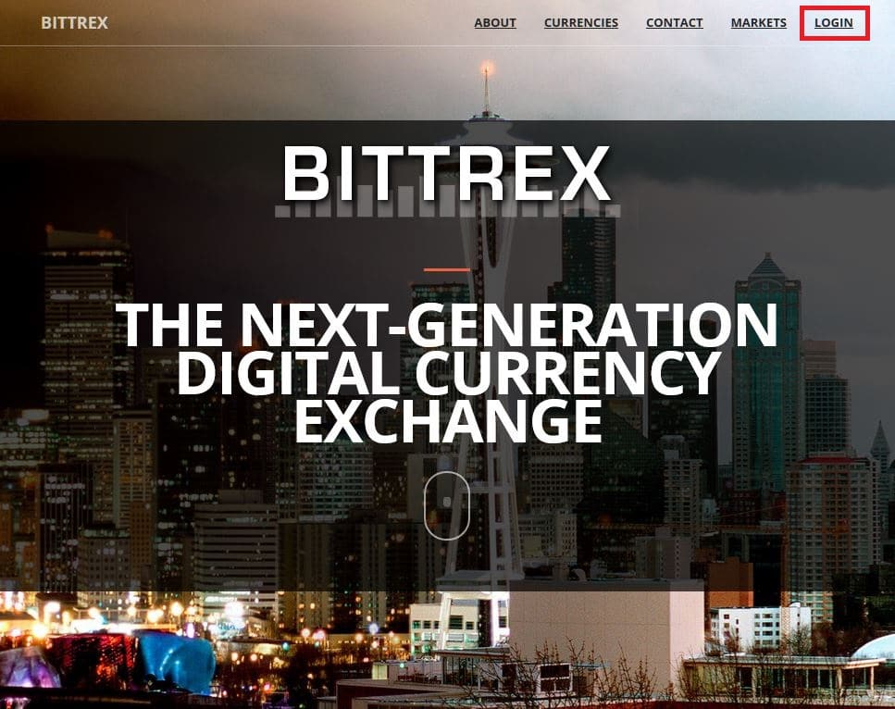

1. After login to **Bittrex** you see the front page of the exchange.
2. Go to the upper part of the page and select **Wallets**.

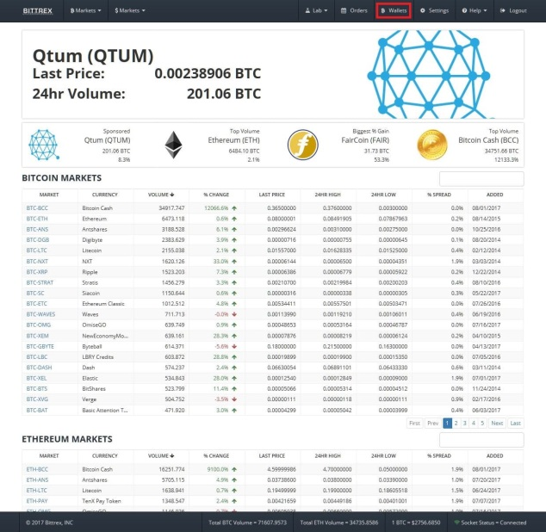

1. Type **Ethereum** in the search. From the **Search** tab you can find your wallet for every currency which is listed in the **Bittrex** exchange.

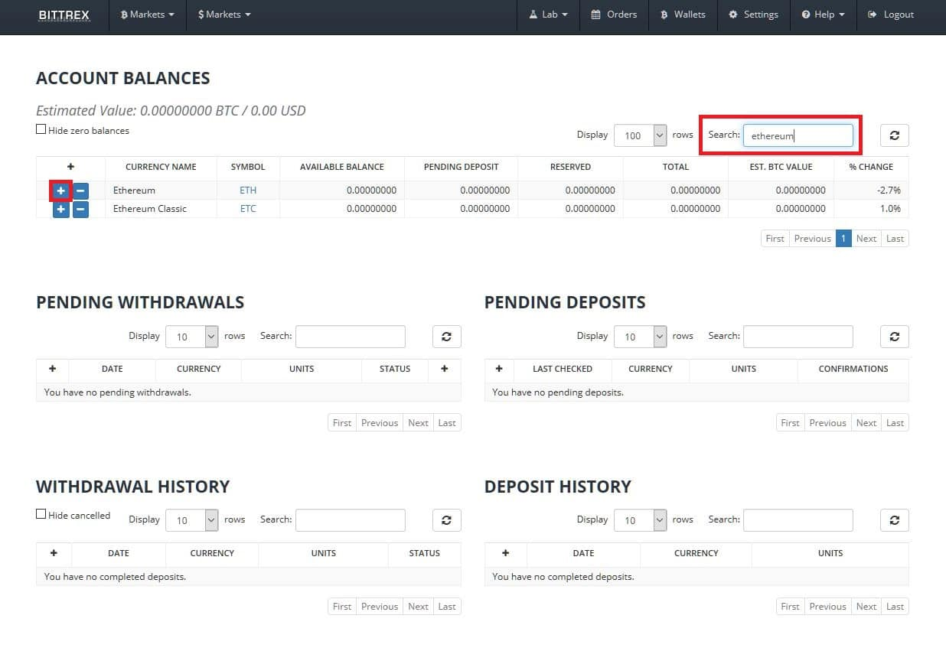

1. Now click the **“plus”** button shown in the screenshot. Next step is to generate your **Ethereum address**.

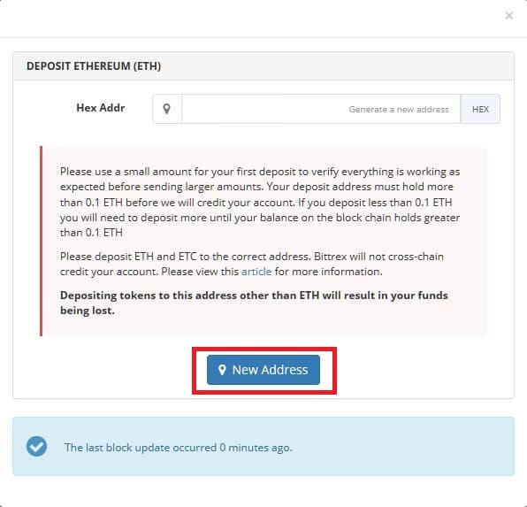

1. After the address is generated, you have to send some ETH funds, which you have bought already. You can buy Ethereum from **Coinbase** or **Bitpanda**. Another option is to send Ethereum from software wallet to your **Bittrex** wallet address.

## Receive your deposit after confirmed by the Blockchain

The next thing to do is to **receive** your **Ethereum** after blockchain **confirmations**. In this particular example, **36 confirmations** are needed before the order is finished (confirmed by the blockchain). After a **transaction** was broadcast to the **network**, it may be included in a **block** that is published to the network. When that happens, it is said **transaction** has been mined at a depth of one block. With each subsequent block found, the number of **blocks** deep is increased by one. To be secure against [double spending](https://en.bitcoin.it/wiki/Double_spending), a transaction should not be considered as **confirmed** until it is a certain number of blocks deep.

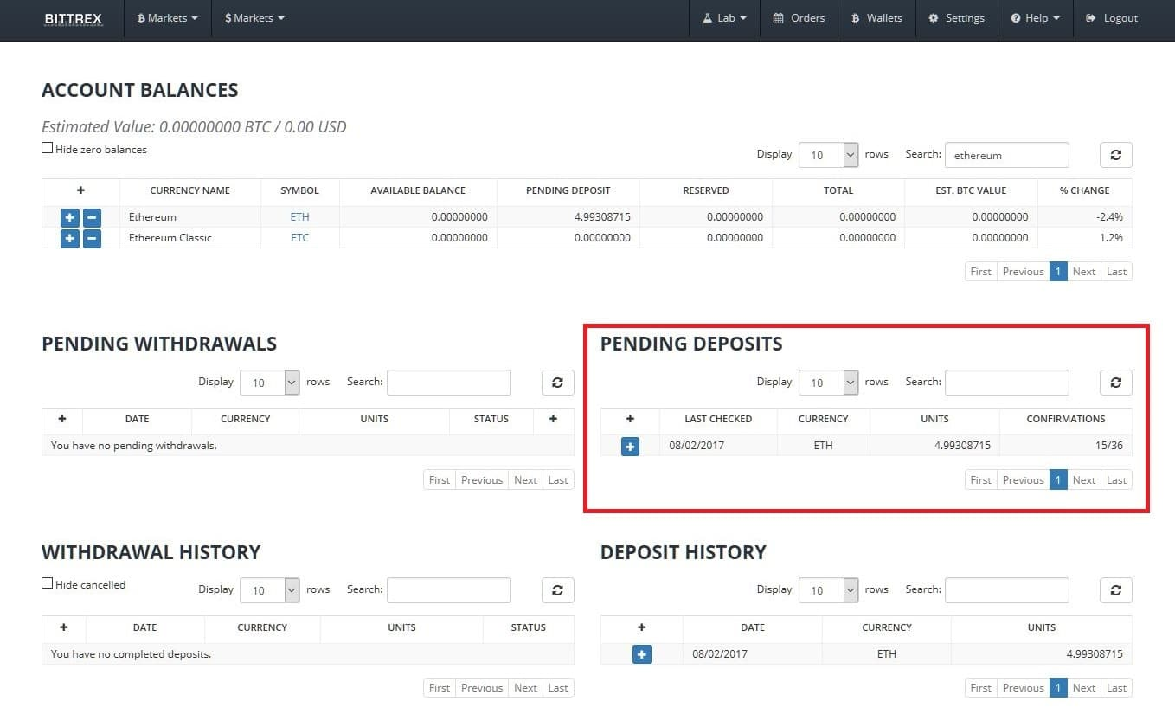

## Place Your Order

Great! Now you have some **ETH** and you can **trade** them from other **altcoins**, which are listed on the **Bittrex** exchange. Basic trading pairs in **Bittrex** are **BTC**, **ETH** and **USDT**. There are markets for these **3** cryptocurrency.   
For example, you can buy many altcoins with Ethereum using the **Ethereum Markets.**

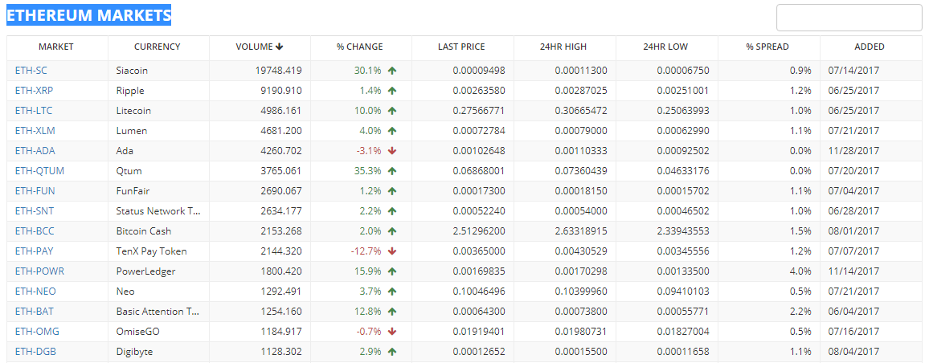

1. Let’s say you want to buy Dash. Type **Dash** in Search tab as shown in the screenshot. Choose the **ETH-DASH** market pair.

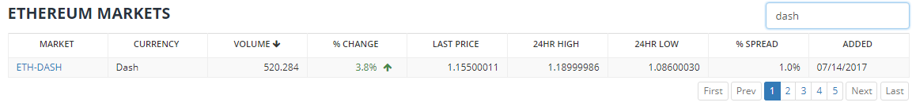

1. Now we will do some **trading**. In order to do that we have to know what **Units**, **Bid**, **Type** and **Total** mean.

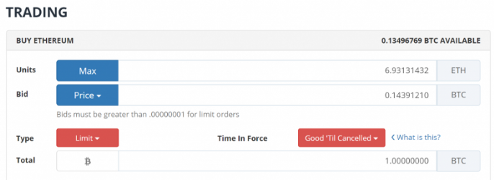

**Units** - This is the number of units you will receive. **Bittrex** will do some math calculations for you, so, you can purchase an arbitrary amount of the desired unit or you can purchase the maximum amount afforded by the number placed in the **Total box below**.

**Bid** - This is the **price** per **unit**.

**Type** - There are two options here, **"Good 'Til Cancelled"** and **"Immediate or Cancel".** **"Good Til Cancelled"** will allow small portions of your order to be executed until it is complete. **"Immediate or Cancel"** requires the full order to be filled immediately, anything else is cancelled.

**Total** - total amount of coin you currently have that you will be spending for the coin you desire to buy. **In this example, we are selling 4.99 ETH in exchange for 5.89 Dash.**

Setting a **SELL ORDER** - A **Sell Zone** is a price range, set by a trader as an ideal place to sell your coin where we feel that it will not continue climbing. This is to allow for maximum profits.

**Sell orders** are very similar to **buy orders**.

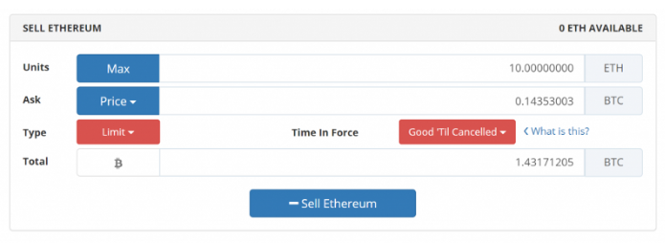

1. **Order book** and how to read it

Bittrex uses **ASKS** and **BIDS** for selling and buying cryptocurrencies. The **BIDS** are on the left side and the **ASKS** on the right side. Other exchanges have the ASK on the left side and BIDS on the right side. Some exchanges use **BUY** and **SELL** orders instead of BIDS and ASKS.

They buy order book represents all buyers in the selected market.

* All the bids in the **BUY** order book
* The amount (size) of coins the buyer wants to buy
* The sum of the amount times the price
* The total sum of the previous buy orders
* The depth of the order book and total amount of coins

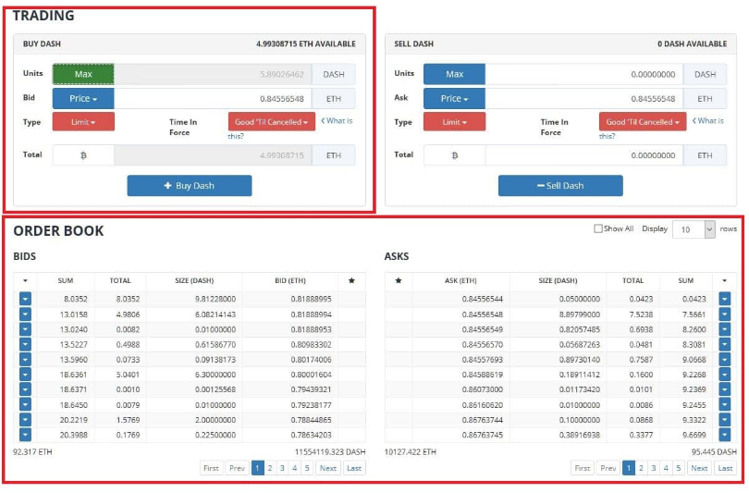

The sell order book looks exactly the same. It consists of:

* All the **ASKS** in the sell order book
* The amount (size) of coins the seller wants to sell
* The sum of the amount times the price
* The total sum of the previous buy orders
* The depth of the order book and total amount of coins

## Completed Order and Withdrawals

Now we have bought **5.89 Dash**. What we can do next is to trade it for another **altcoin**, buy **Bitcoin**, **Litecoin**, etc. After we have decided we are done with trading, we can **withdraw** our coins to a software or hardware wallet where they will be safe (or at least safer than on an exchange).

## Now click the “minus” button shown in the screenshot.

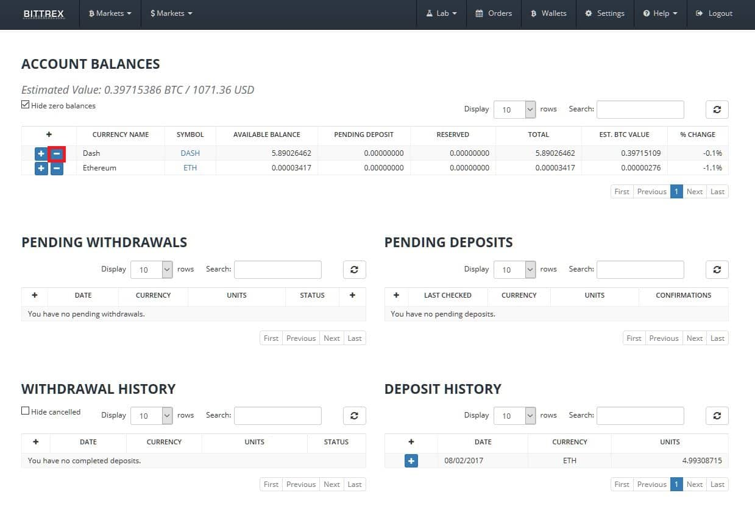

## Enter amount and address where you want your withdrawal sent. Usually this is the address of your coin you withdraw but in the hardware or software wallet.

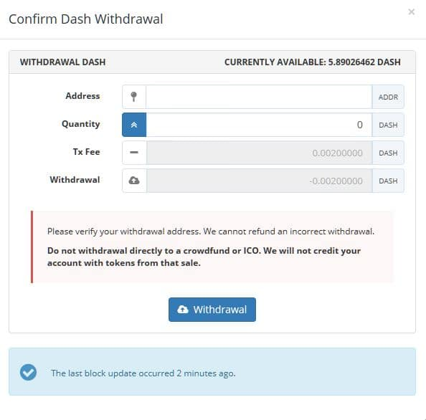

After the successful trades, you can withdraw you assets again in your **Jaxx** or **Exodus** wallet. **Dash** is supported by both wallets.

# What to Submit?

At the end of the exercise, you should return some funds in your Jaxx wallet you have installed in the previous exercise.